Laura Ward
S1712368 | Computer Games (Design)
Disclaimer
I confirm that the code contained in this file (other than that provided or authorised) is all my own work and has not been submitted elsewhere in fulfilment of this or any other award.
Laura Ward

Brickout
ITGP Year 1 Coursework

Contents
1. Project Overview 2
2. Code Description 2
2.1. Paddle Movement 2
2.2. Ball Movement 3
3. Challenging Code 3

1. Project Overview
For my Introduction to Games Programming course, I have been tasked with trying to recreate the game Breakout using Unity and C# code within Microsoft Visual Studio to program the game.

2. Code Description

2.1. Paddle Movement
For the movement of the paddle within the game, I largely tried to replicate that which we used within the labs for our practical classes. The important areas within this script are the defining of major variables used within the script – the keycode variables, Boolean variables, and float variables determining the speed and direction of the paddle.
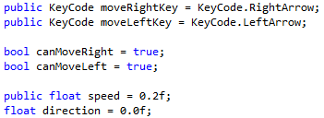
Figure 1 Variables
There are two update functions, one which determines the speed and position the paddle is going using Vector3 positioning; the other detecting which keypresses the user is inputting into the game and what to do in each scenario.
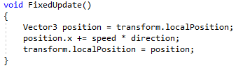
Figure 2 Update function determining speed and position of paddle
In order to fix the issue of the paddle going through the side boundaries, I used switch statements to detect collision between the paddle and the left and right walls. By using this, the game can detect whether or not the paddle is colliding with the left or right walls and what to do in each instance.
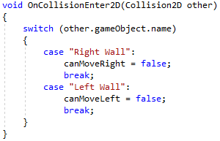
Figure 3 Switch statement detecting collision between paddle and walls

2.2. Ball Movement
For the ball movement within the game, I defined the variables for the speed and the movement of the ball, as well as the variables for Rigidbody2D and the location of the ball in relation to the paddle. There is an update function for the ball movement which detects whether or not the ball is moving and what happens in that instance and the paddle controls.
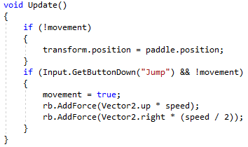
Figure 4 Update function for detecting ball movement and paddle controls
There is also collision detection for the ball falling into the out of bounds area on the bottom of the screen, as well as for the ball colliding with the bricks and destroying them.
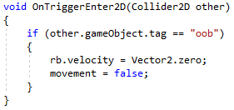
Figure 5 Collision detection between ball and out of bounds area

3. Challenging Code
An area of code I had difficulty implementing was the code which detected the collision between the ball and the bricks and the subsequent destruction of the bricks after the collision. Initially, this was due to the fact I had not given the bricks the same tag, and therefore did not know how to implement code which would connect with every single brick without writing an excess amount. However, once I understood that I could give the bricks the same tag within Unity to group them together to aid my coding within Visual Studio, I then looked at some of the labs we had used in class to help with the collision detection and destruction. This ended with me being able to write code which detected the collision between the ball and the bricks, identify the tag for the bricks as game objects, and then have these be destroyed when colliding with the ball.
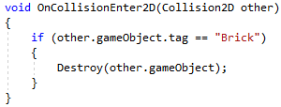
Figure 6 Collision detection between the ball and the bricks

